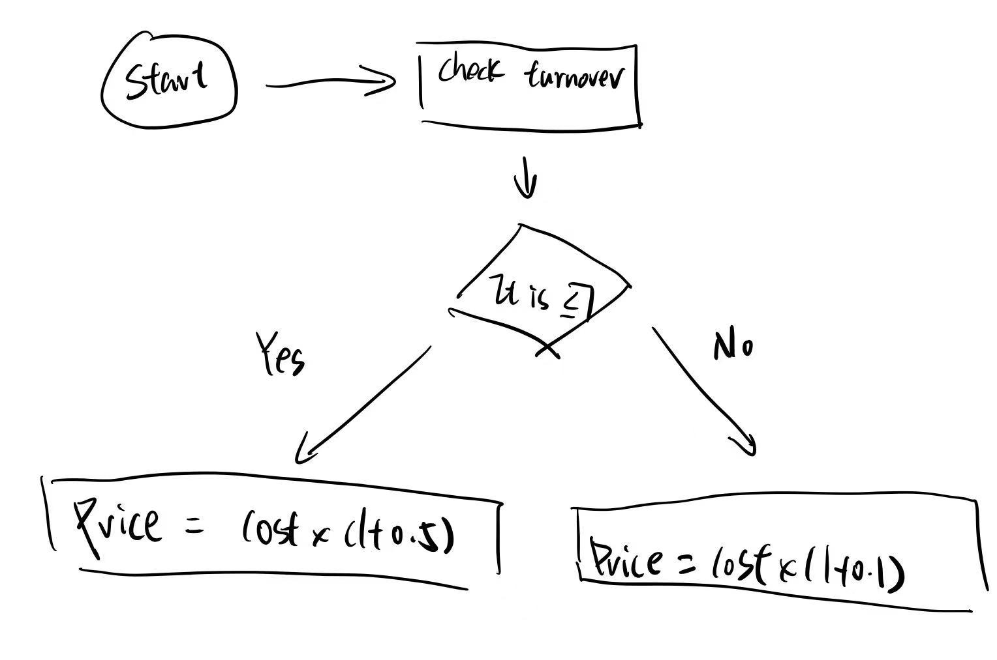***Part1 flowchart***

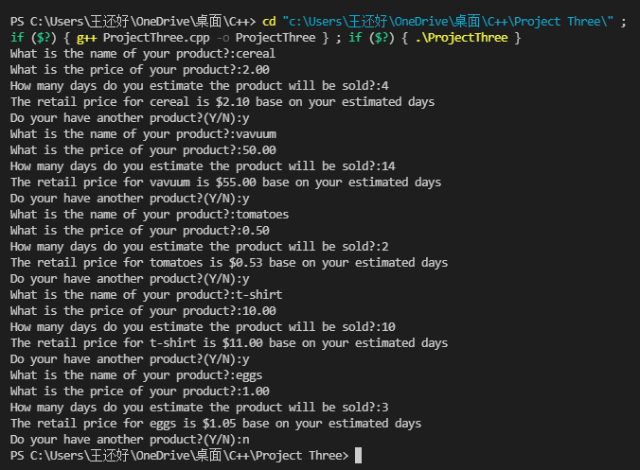

***Part2 snapshots of your executions***

/will

Cs002

May 18 2021/

#include<iostream>

#include<iomanip>

using namespace std;

void calculateRetail(double cost,int turnover,double &price)

// Precondition : Write price algorithm and formula in calculateRetail()

{

if(turnover<=7)

price = cost * (1 + 0.05);//price calculate and sent to calculateRetail function

else

price = cost * (1 + 0.1);//price calculate and sent to calculateRetail function

}

//Postcondition: Retail price has been calculated and initialized in the price variable.

void getInput(double &cost, int &turnover,char *product,double &price)

// Precondition :User is ready to enter values correctly and substituted into calculateRetail() for calculation.

{

cout << "What is the name of your product?:";//user ready to input the values

cin >> product;

cout << "What is the price of your product?:";

cin>> cost;

cout << "How many days do you estimate the product will be sold?:";

cin>>turnover;//value is set to the user's input

calculateRetail(cost, turnover, price);

cout << "The retail price for " << product << " is $" << fixed << setprecision(2) << price << " base on your estimated days" << endl;

}

//Postcondition :The values is set to the user’s input and calculate the result through calculateRetail().

int main()

{

double cost;

int turnover;

char product[20];

double price;

char judge;

while(1)

{

getInput(cost,turnover,product,price);

calculateRetail(cost,turnover,price);

cout << "Do your have another product?(Y/N):";

cin >> judge;

if(judge!='Y'&&judge!='y')

break;

}

return 0;

}***Part 4 copy and paste your final version of your code***

All the work is done by Will

***Part5 task division***